Lab 1: Introduction to SPSS

Introduction
In this lab course, we shall introduce you to a computer program for carrying out various statistical analyses called Statistical Package for the Social Sciences, or SPSS, in short. The very first version of SPSS was intended to cater to the social scientists, but its applications now cater to a large spectrum of professionals. Its features are designed in a way that both social scientists as well as non–social scientists benefit from them. It can perform simple tasks as well as doing some sophisticated analyses.

Through these labs, we shall attempt to cover the most fundamental features of SPSS, so that, by the end, you will be acquainted with the necessary basic skills in entering, reorganizing, and presenting data. You will also be able to run your own data analyses using SPSS. The labs are also designed as a stepping stone or a foundation for advanced skills in SPSS usage. The labs will utilize data with real-life examples. Each participant will have hands-on practice with performing the basic SPSS manipulations and computations. At the end of the course you will be able to:
- Perform data analysis for educational research using SPSS;
- Produce and customize a range of tabular and graphic displays;
- Compute, display, and interpret summary statistics.

The labs draw upon initiatives supported by the Council of Ministers of Education, Canada (CMEC), in terms of providing students with the data that will be used during the learning tasks. CMEC is an intergovernmental body that provides leadership in education at the pan-Canadian and international levels. The specific branch of their work that is of particular interest to this course is the Pan-Canadian Assessment Program (PCAP), which is a cyclical test of achievement that aims to measure students’ performance in mathematics, reading, and science. The labs administered throughout this course will use the PCAP 2013 data collected from Alberta.
1. Open SPSS
Typically, you can find SPSS in All Programs → SPSS → SPSS 24.0. Once you see this blank screen, you are now ready to enter your data.
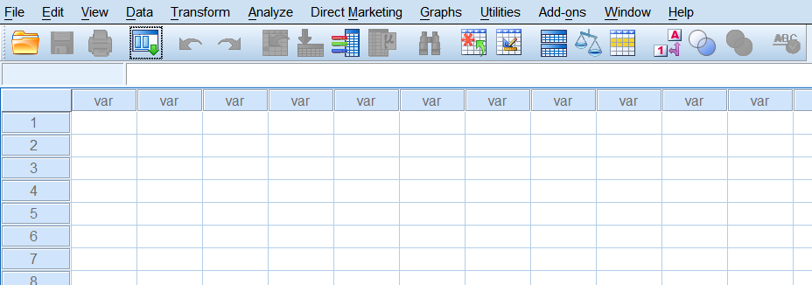

2. Entering your data set
The next few sections will guide you through how to manually enter this data set, shown below, into SPSS. This data set shows the results of a survey you recently administered to understand the effects of bullying on students’ science test scores. You collected some demographic information about your participants as well. Please complete all sections of items 3a to 3e before you start to enter this data.
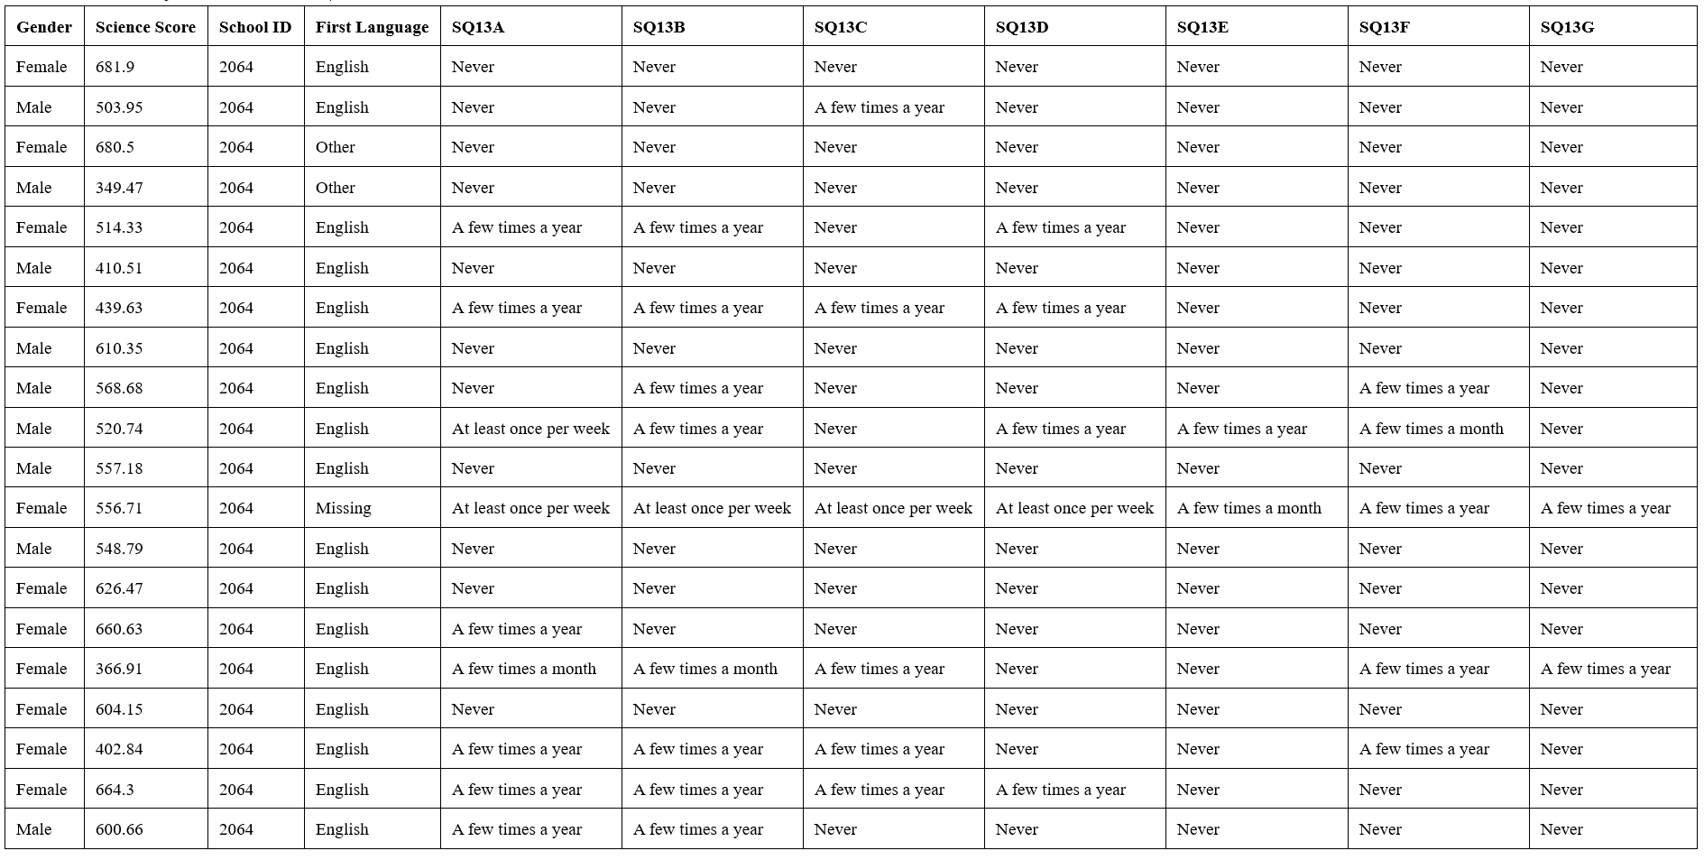

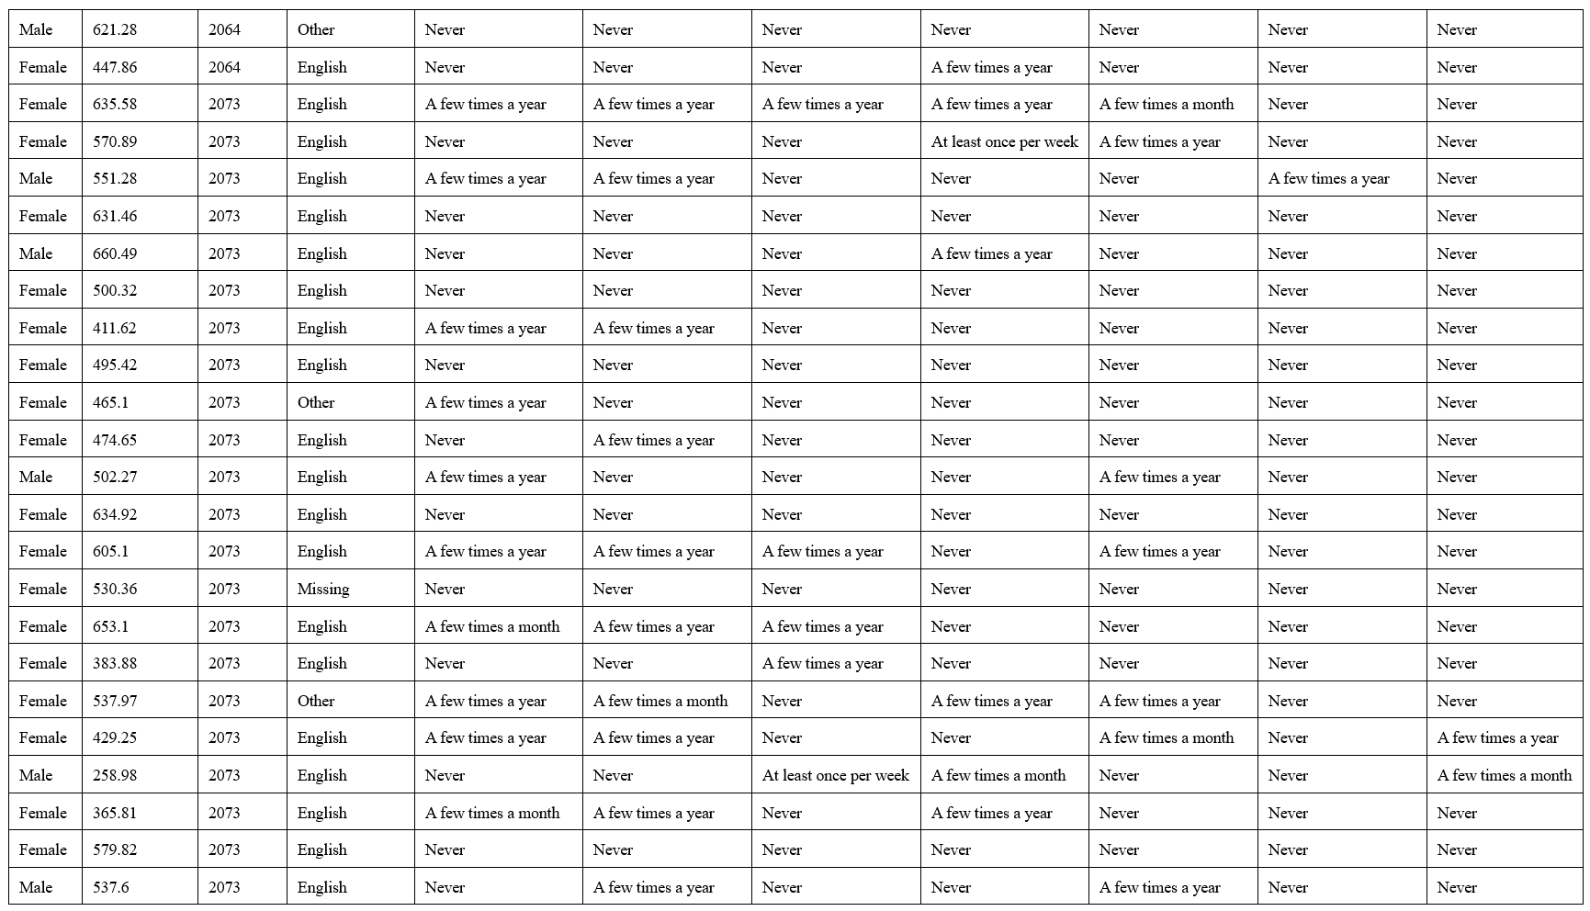

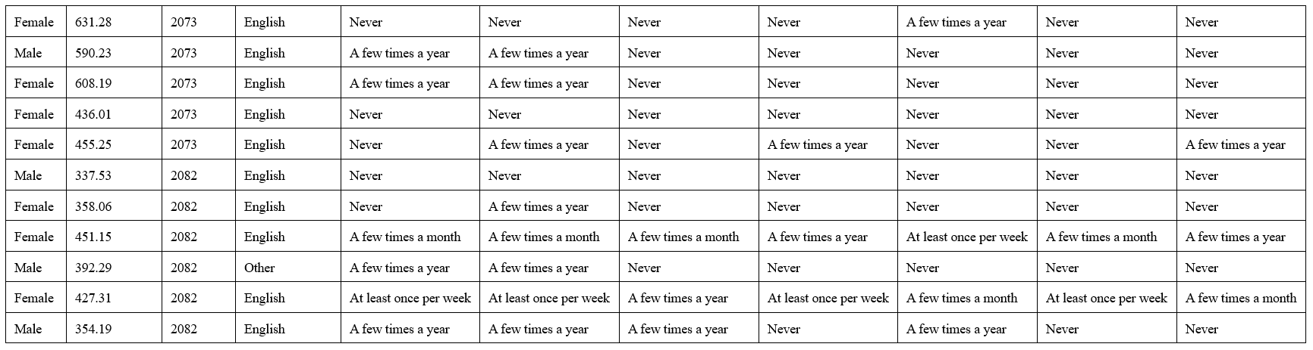
3. Using the “Variable View” tab (located on the bottom of the screen), please try to enter information about each variable.
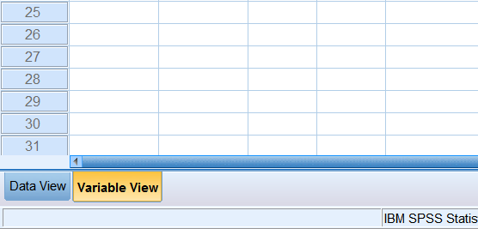

3a. Variable naming: type the names for the variables (SPSS does not like spaces, consider using underscores: _.)
Question:
1. What item does SQ13A, SQ13B, SQ13C, SQ13D, SQ13E, SQ13F, and SQ13G represent? Please write out the actual item below: (Hint: use the PCAP codebook.)
____________________________________________________________________________________________________________________________________________________________________________________________________________________________________________________________________________

3b. Variable type: specify the types for the variables.
Consider what type of data you will be entering for each variable and label the types of variable, either numeric or string. (Consider searching Google for: “types of variables in SPSS” – there are many great online resources to help you with SPSS.)
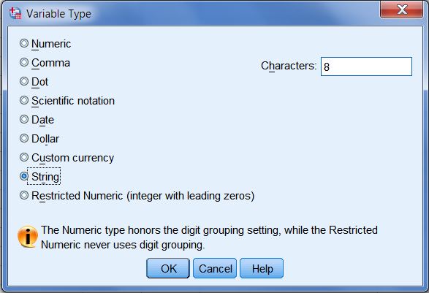
Question:
2. Determine the type of variable: discrete/continuous.
Gender: ________________________________
Science Score: __________________________________
School ID: ___________________________________
First Language:_____________________________________
SQ13A:______________________________________

3c. Measures: SPSS does not use the terms discrete and continuous; instead they use the terms scale, ordinal, and nominal. Please set the appropriate measure for each variable.
Question:
3. Please describe or define: scale, ordinal, and nominal.

3d. Width and decimal places: Please set the appropriate number of digits you will enter and the number of decimal places for each variable. This is good practice because it helps to prevent some typos. For example, if you set up this variable to contain only 1 digit, you cannot type ‘12’ for Gender, because this variable is set up only for single-digit entries. Click the little “pointing downwards” arrow to reduce the number of width and decimal places or vice versa.

3e. Label: Please enter a descriptive label for each of the variables. For your own data sets, you may need to refer to these labels a few months later, so make sure these labels are done well. Re-entering data is NOT fun, so ensure all variables are well labelled!
Question:
4. Please enter the appropriate labels for ALL variables in your data set. For example, write the items from Question 1 into the label for each of the SQ13 items.

3f. Values: Since Gender is a categorical variable, we need to assign a number to indicate each category. For example, male and female (let SPSS know). Let’s say “1” = Male and “2” = Female. Click the little grey box next to None under Values. Type “1” and “Male”, and then click Add. Type “2” and “Female”, and then click Add. Click OK.
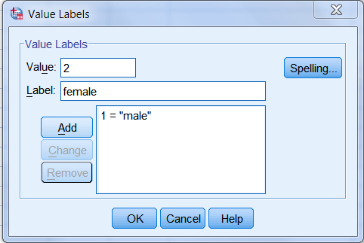
You will need to consult the PCAP 2013 Student Codebook_EN.pdf document to determine the codes, if any, used for the other variables.

4. Entering your data
Using the “Data View” tab (located at the bottom of the screen), please try to enter your data and save the file (the file type for SPSS data is “.sav”).
Note that we specify “1” as Male and “2” as Female. If you want to verify them, click
View → Value Labels.

5. Basic data management

5a. Sorting data (Data → Sort cases); for example, sort by Science Score.
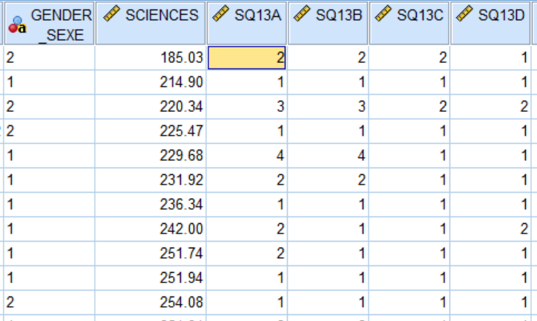
This is useful when you are trying to view your data in a specific order.

5b. Setting missing values (in the Variable View tab): We sometimes encounter problems of missing data in data collection, e.g., some participants did not report their First Language. It is better for us to reserve a special value to indicate the missing value in SPSS so that we do not think we accidentally left it blank. (For example, “-9” or “-8” are good choices, because we will probably not accidentally enter such values on a Likert scale from 1 to 4.)

Question:
5. What missing value would you like to specify for Science Score? (Hint: it should be a value that you would not accidentally enter.)

You have now completed the lab.

